**BT307 LAB 6**

**1) Name:** Aditya Jindal

**2) Roll No.:** 210106004

**3)**

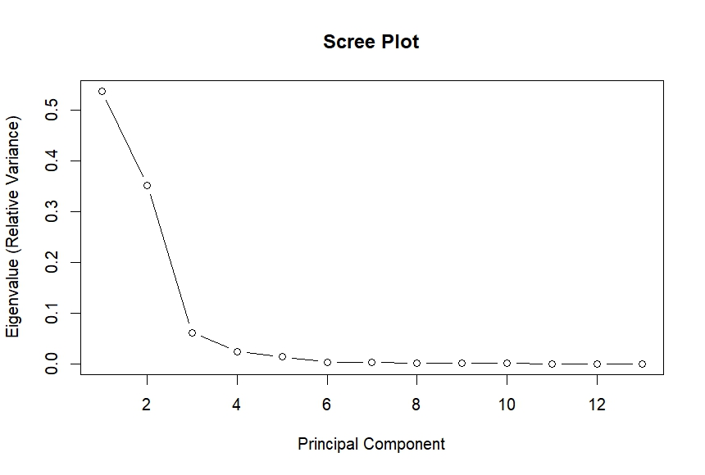

**4)**

The principal components we choose to further study are: PC1 and PC2.

**5)**

